

Semester Two Examination, 2016

Question/Answer Booklet

MATHEMATICS

SOLUTIONS
APPLICATIONS
UNITS 3 AND 4

Section One:

Calculator-free

Student Number: In figures

In words

Your name

Time allowed for this section
Reading time before commencing work: five minutes
Working time for section: fifty minutes

Materials required/recommended for this section
To be provided by the supervisor
This Question/Answer Booklet
Formula Sheet

To be provided by the candidate
Standard items: pens (blue/black preferred), pencils (including coloured), sharpener, correction fluid/tape, eraser, ruler, highlighters

Special items: nil

Important note to candidates
No other items may be taken into the examination room. It is your responsibility to ensure that you do not have any unauthorised notes or other items of a non-personal nature in the examination room. If you have any unauthorised material with you, hand it to the supervisor before reading any further.

Structure of this paper

Section | Number of questions available | Number of questions to be answered | Working  time (minutes) | Marks available | Percentage of exam
Section One:  Calculator-free | 8 | 8 | 50 | 52 | 35
Section Two:  Calculator-assumed | 13 | 13 | 100 | 97 | 65
 |  |  | Total | 149 | 100

Instructions to candidates

1. The rules for the conduct of examinations are detailed in the school handbook. Sitting this examination implies that you agree to abide by these rules.

2. Write your answers in this Question/Answer Booklet.

3. You must be careful to confine your response to the specific question asked and to follow any instructions that are specified to a particular question.

4. Spare pages are included at the end of this booklet. They can be used for planning your responses and/or as additional space if required to continue an answer.
- Planning: If you use the spare pages for planning, indicate this clearly at the top of the page.
- Continuing an answer: If you need to use the space to continue an answer, indicate in the original answer space where the answer is continued, i.e. give the page number. Fill in the number of the question that you are continuing to answer at the top of the page.

5. Show all your working clearly. Your working should be in sufficient detail to allow your answers to be checked readily and for marks to be awarded for reasoning. Incorrect answers given without supporting reasoning cannot be allocated any marks. For any question or part question worth more than two marks, valid working or justification is required to receive full marks. If you repeat any question, ensure that you cancel the answer you do not wish to have marked.

6. It is recommended that you do not use pencil, except in diagrams.

7. The Formula Sheet is not to be handed in with your Question/Booklet.

Section One: Calculator-free 35% (52 Marks)
This section has eight (8) questions. Answer all questions. Write your answers in the spaces provided.

Working time for this section is 50 minutes.

Question 1 (5 marks)
(a) Re-draw the following graph to clearly illustrate that it is planar. (2 marks)

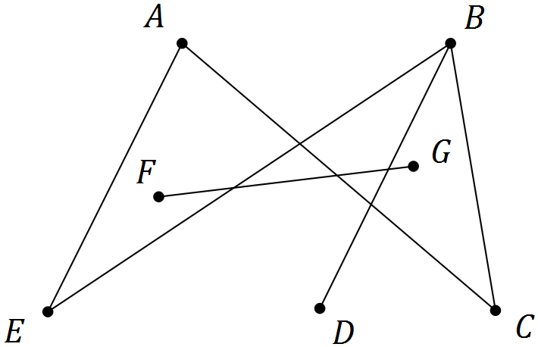
Solution
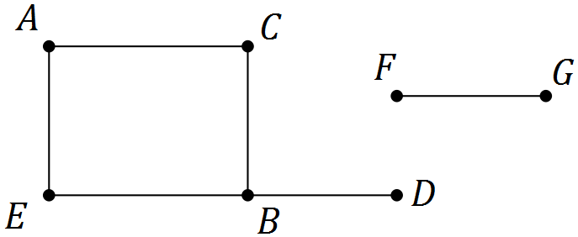

Specific behaviours
graph has no edges that cross
correct, disconnected version of graph

(b) A digraph is shown below.

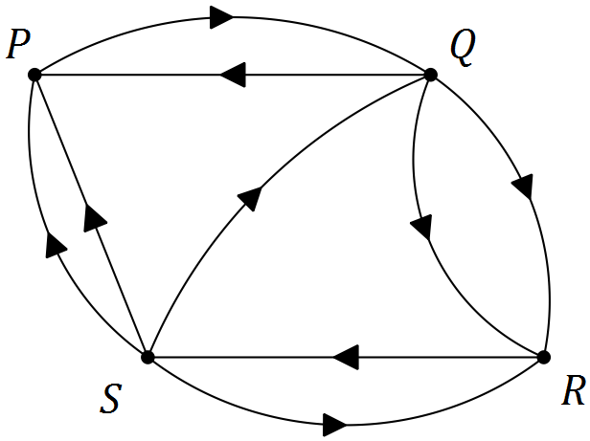

(i) Construct an adjacency matrix $M$ from the digraph. (2 marks)
Solution
$$\begin{matrix} & & \text{To} \\ & & \begin{matrix}P & Q & R & S\end{matrix} \\ \text{From} & \begin{matrix}P \\ Q \\ R \\ S\end{matrix} & \left[\begin{matrix}0 & 1 & 0 & 0 \\ 1 & 0 & 2 & 0 \\ 0 & 0 & 0 & 1 \\ 2 & 1 & 1 & 0\end{matrix}\right]\end{matrix}$$

Specific behaviours
at least 14 elements correct using from/to convention unless labelled otherwise
all 16 elements correct

(ii) Explain what information the matrix $M^{2}$ would show. (1 mark)
Solution
The number of two stage pathways between vertices in the graph

Specific behaviours
explanation

Question 2 (7 marks)
The number of laptop computers, $T_{n}$, that were brought to a school IT department for recharging during week $n$ of the school year can be described recursively by the rule

$$T_{n+1}=T_{n}+3, T_{4}=16$$

(a) Use the rule to complete the table below. (2 marks)

$$n$$ | 1 | 2 | 3 | 4 | 5 | 6 | 7
$$T_{n}$$ | 7 | 10 | 13 | 16 | 19 | 22 | 25
Solution
See table
Specific behaviours
writes terms for $n=4,5,6,7$
writes terms for $n=1,2,3$

(b) Display the terms of the sequence from the table on the graph below. (2 marks)

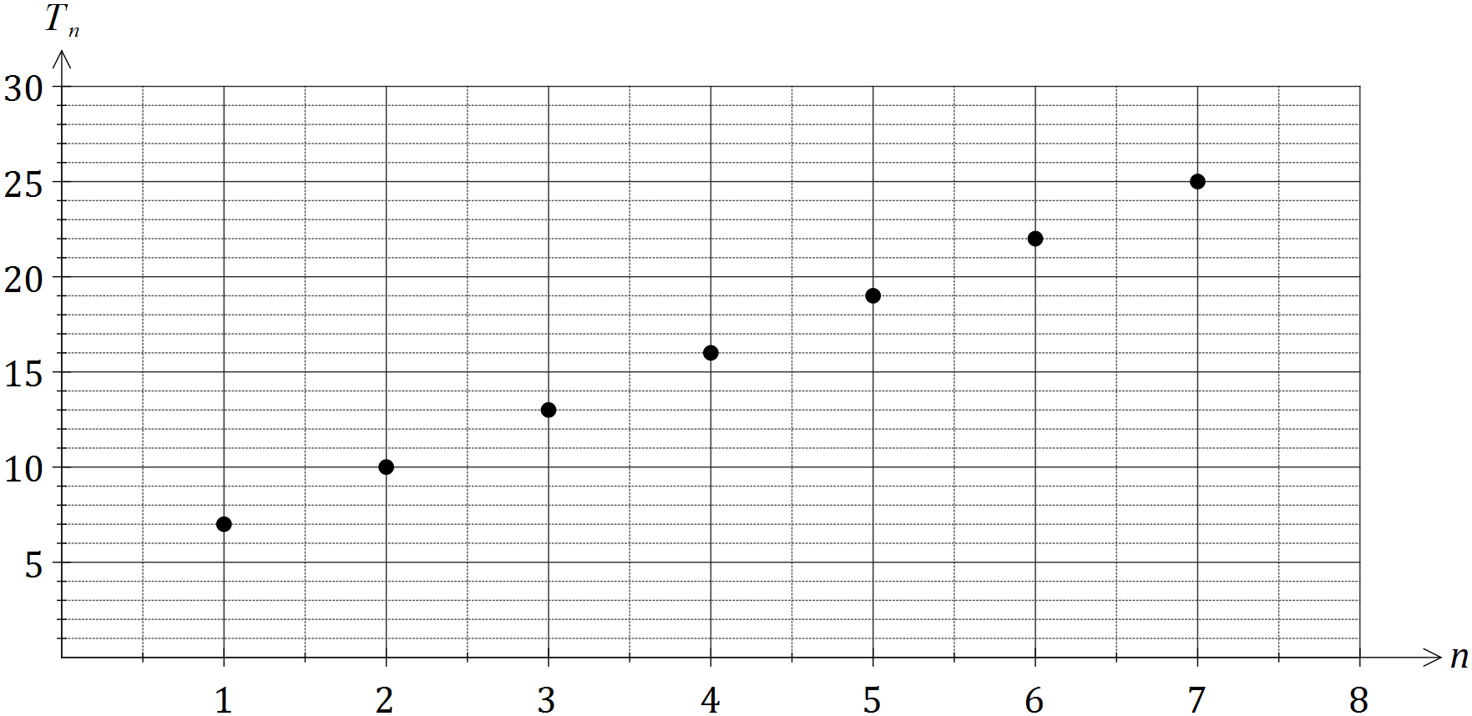
Solution
See graph
Specific behaviours
plots at least five points accurately
plots seven points accurately, no attempt to join them

(c) A rule to determine the number of laptops brought for recharging during week $n$ can also be written in the form $T_{n}=an+b$. Determine the values of $a$ and $b$. (2 marks)
Solution
$T_{n}=7+\left(n-1\right)\left(3\right)=3n+4$
$a=3, b=4$

Specific behaviours
determines value of $a$
determines value of $b$

(d) If the pattern continued, determine the number of the week during which the number of laptops brought in for recharging first exceeds 50. (1 mark)
Solution
$3n+4=50, n=15\frac{1}{3}.$ During week 16.

Specific behaviours
states correct week

Question 3 (6 marks)
The network below shows the distances, in kilometres, between nine towns, P, Q, R, ..., X.

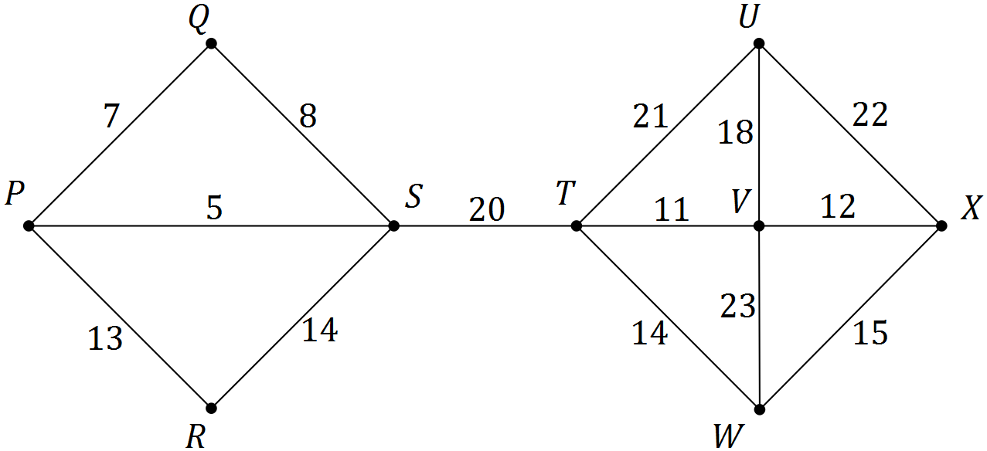

(a) Use Prim's algorithm, starting from P, to determine a minimum spanning tree for the network and draw the minimum spanning tree below. (3 marks)

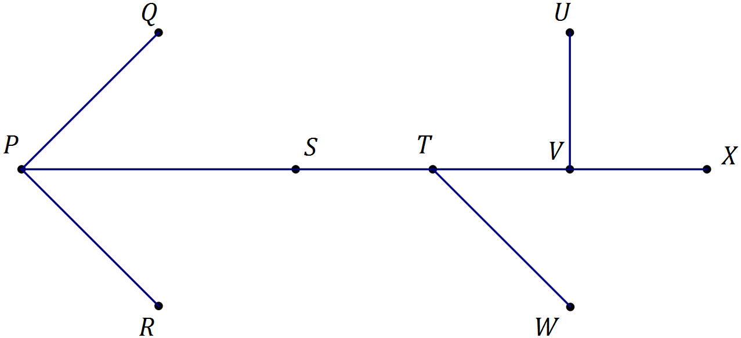
Solution
Highlights given network, draws tree

Specific behaviours
shows at least 7 correct edges
shows all required edges
draws tree, no cycles

(b) State the length of the minimum spanning tree. (1 mark)
Solution
$5+7+13+20+11+12+14+18=100$ km

Specific behaviours
states length

(c) Prim's algorithm from different starting points produces the same minimum spanning tree for this network. State the final edge that would complete the minimum spanning tree using Prim's algorithm:

(i) starting from S. (1 mark)
Solution
Final edge: VU

Specific behaviours
states edge

(ii) starting from W. (1 mark)
Solution
Final edge: PR

Specific behaviours
states edge

Question 4 (7 marks)
The table below shows the number of members, $N$, of a swimming club who turned up for training over the first three weeks of winter. The club trained on Monday, Tuesday, Wednesday and Thursday each week.

 | Week 1 |  |  |  | Week 2 |  |  |  | Week 3
Day | M | T | W | T | M | T | W | T | M | T | W | T
Time, $t$ | 1 | 2 | 3 | 4 | 5 | 6 | 7 | 8 | 9 | 10 | 11 | 12
Number, $N$ | 35 | 33 | 19 | 21 | 32 | 29 | 4 | 21 | 30 | 25 | 19 | 20

(a) Construct a time series plot of this data on the axes below. (2 marks)
Solution
See graph
Specific behaviours
plots at least six points correctly
plots all points correctly
(no requirement to connect points)

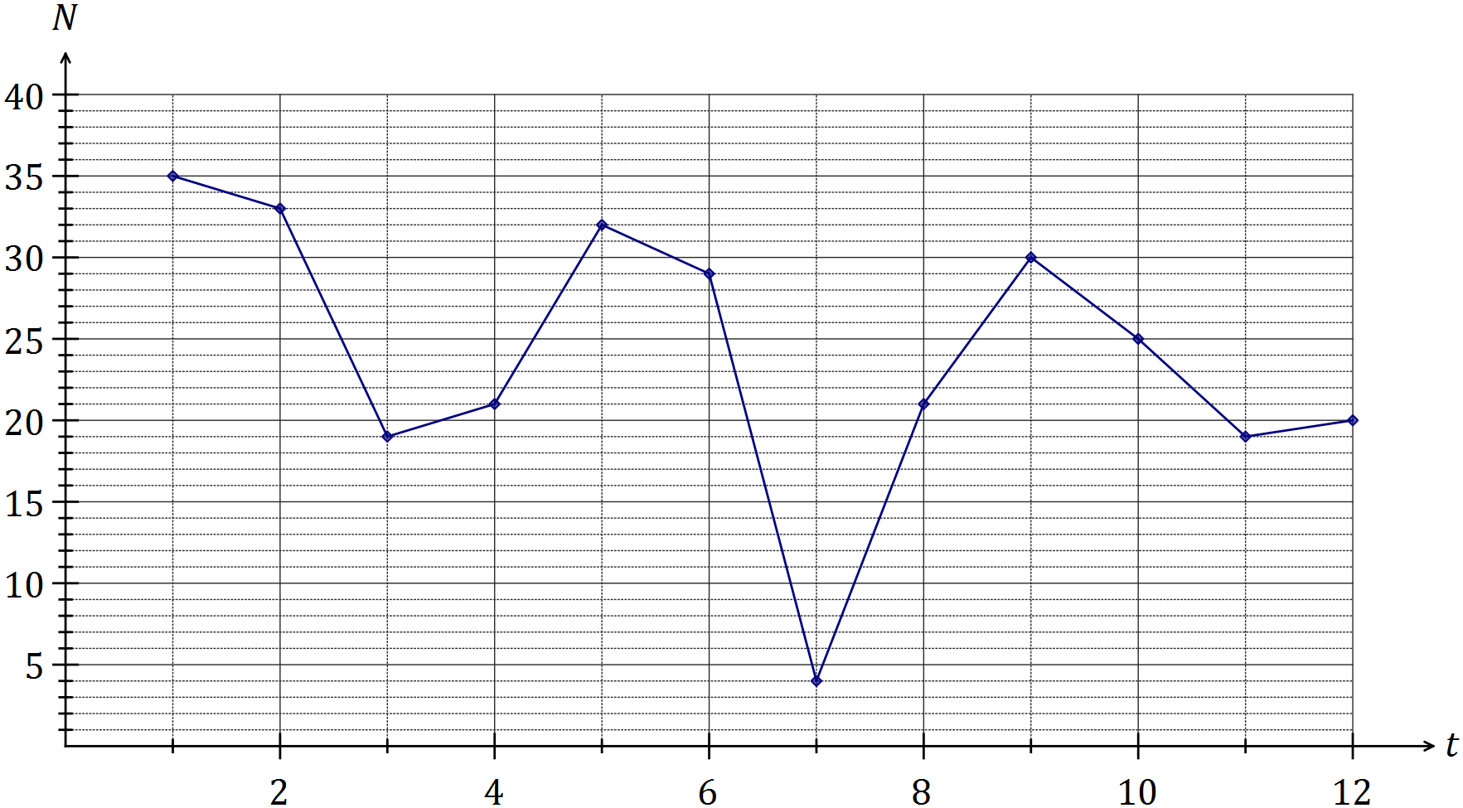

(b) Comment on features of the time series plot, including trend and seasonality. (3 marks)
Solution
Trend is decreasing - fewer members are turning up each day
Weekly (4 day) seasons, with most on Mons and least on Weds
Likely outlier on Wed of Wk 2, much lower than other two Weds

Specific behaviours
comments on decreasing trend
comments on seasons
comments on outlier, or other relevant feature

(c) The trend line for the data is $N=30-0.9t$. Comment on the usefulness of this line as a short and long term trend model. (2 marks)
Solution
Model is useful in the short term but not in the long term as it predicts a negative number of swimmers after just over 30 days, which makes no sense.

Specific behaviours
indicates useful in short term but not in long term
includes at least one reason in response

Question 5 (6 marks)
(a) When collecting data as part of a statistical investigation, state a reason why a student

(i) may choose to take a sample from the population under study. (1 mark)
Solution
Easier; Quicker; Not possible to locate all members of population; etc

Specific behaviours
states a valid reason

(ii) would prefer a large sample rather than a small sample. (1 mark)
Solution
Larger samples tend to be less biased/give more valid results/etc

Specific behaviours
states a valid reason

(b) A student investigated the relationship between the number of emails, $x$, and the number of text messages, $y$, received by nine people during a weekday and found that there was a weak negative linear relationship between the variables.

(i) Use the axes below to sketch a possible scatter plot that reflects this information.
(2 marks)
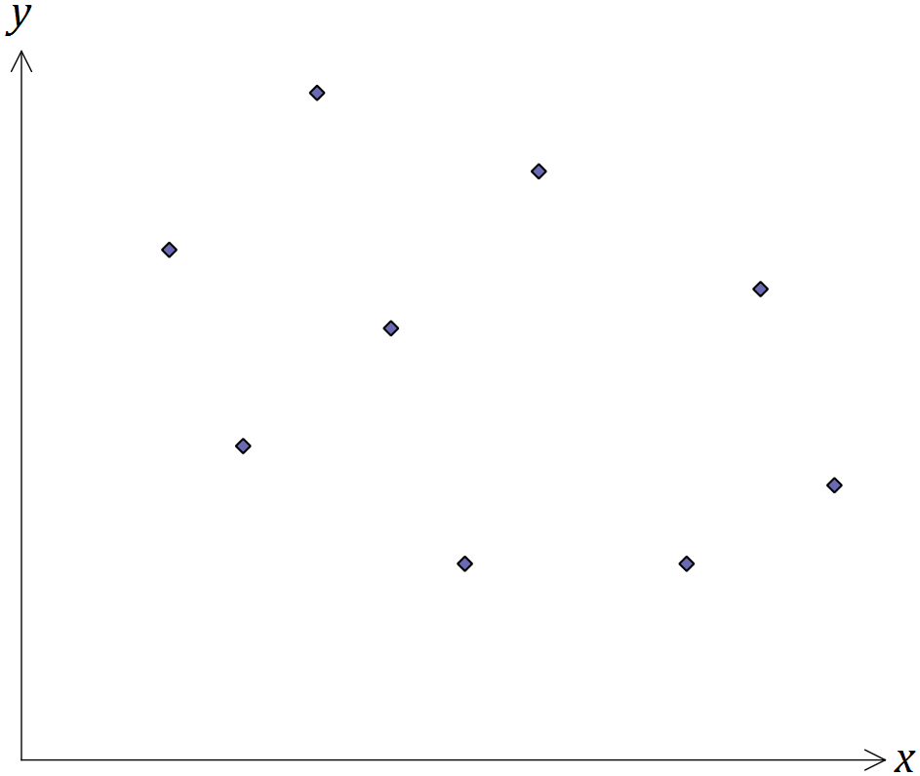
Solution
See graph
Specific behaviours
clear negative trend
'oval' with nine points

(ii) Place a cross on the scale below for the best estimate you can make for the value of the correlation coefficient between the two variables. (1 mark)

Solution
See number line
Specific behaviours
places cross between -0.2 and -0.5

(iii) Suggest a reason for the relationship the student found. (1 mark)
Solution
Personal preference to use one rather than both forms of communication

Specific behaviours
any plausible reason

Question 6 (6 marks)
(a) A simple connected graph has 4 edges and $V$ vertices. State all possible values of $V.$
(2 marks)
Solution
$$\left(V=\right) 4 \text{or} 5$$

Specific behaviours
either value
both values, no others

(b) A simple connected graph has $E$ edges and 4 vertices. State all possible values of $E.$
(2 marks)
Solution
$$\left(E=\right) 3, 4, 5 \text{or} 6$$

Specific behaviours
at least three correct
all values, no others

(c) Draw a simple connected graph that has 5 vertices and is Eulerian but not Hamiltonian.
(2 marks)
Solution
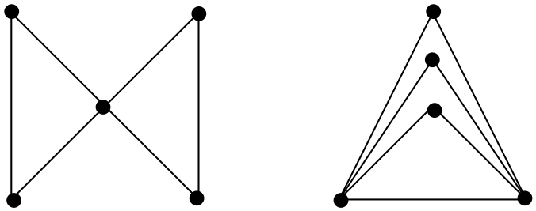

Specific behaviours
draws simple connected graph with 5 vertices, all vertices even degree
draws one of above (or isomorph)

Question 7 (7 marks)
The table below shows all but one of the seasonal indices for the daily sales figures for a recently opened pop-up store that is closed on Mondays and Tuesdays.

Day | Wednesday | Thursday | Friday | Saturday | Sunday
Seasonal index | 0.65 | 0.70 |  | 1.35 | 1.50

(a) Determine the seasonal index for Friday. (2 marks)
Solution
$0.65+0.7+1.35+1.5=4.2$
$5-4.2=0.8$

Specific behaviours
indicates given values must add to 5
evaluates missing index

(b) One weekend, the pop-up store had sales worth $3 000 on Saturday and $3 000 on Sunday. If these sales figures were deseasonalised, which day would have the highest sales? Justify your answer. (2 marks)
Solution
Saturday.

$3000÷1.35$ will be bigger than $3000÷1.5$.

Specific behaviours
chooses Saturday
gives a reasonable explanation

(c) The equation of the trend line for deseasonalised sales, $S$ in dollars, after the store had been open for $t$ days was $S=195t+1640$.

(i) Interpret the value of the slope of this line in this context. (1 mark)
Solution
Sales are increasing by $195 per day that store is open.

Specific behaviours
states sales are increasing by 195 per day

(ii) Write down an expression that would forecast the actual sales of the pop-up shop on the Wednesday when $t=31$. Do not evaluate your expression. (2 marks)
Solution
$$(195×31+1640)×0.65$$

Specific behaviours
substitutes time into trend line
multiplies trend value by seasonal component, using brackets

Question 8 (8 marks)
A school has received quotes from venues A, B, C and D to host teams of students to play knockout competitions in basketball, hockey and volleyball. The four venues can only host one sport at a time and their quotes, in hundreds of dollars, for each sport are shown below.

 |  | Sport
 |  | Basketball | Hockey | Volleyball
Venue | A | 28 | 23 | 23
 | B | 27 | 23 | 30
 | C | 25 | 26 | 22
 | D | 30 | 24 | 27

(a) If venues B, C and D are chosen for basketball, hockey and volleyball respectively, calculate the total cost. (1 mark)
Solution
$27+26+27=80⇒\$8 000$ total cost

Specific behaviours
calculates total cost

(b) Represent the choice of venues for each sport as a bipartite graph. (2 marks)
Solution
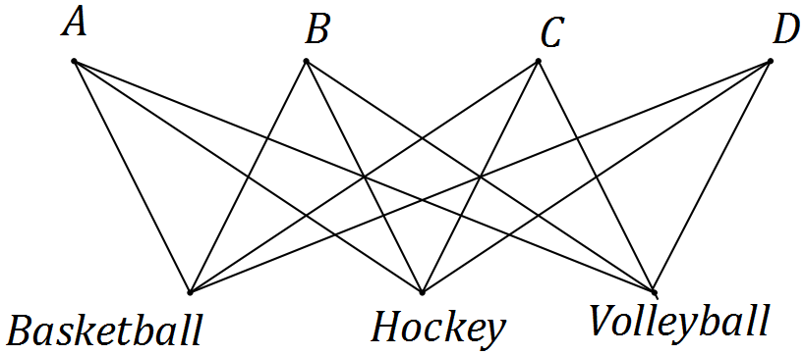
Specific behaviours
two distinct sets of points
joins to create complete bipartite graph

(c) Show use of the Hungarian algorithm to determine a suitable allocation of sports to venues in order to minimise the total cost, and state the minimum cost. (5 marks)
Solution
$\left[\begin{matrix}28 & 23 & 23 & 0 \\ 27 & 23 & 30 & 0 \\ 25 & 26 & 22 & 0 \\ 30 & 24 & 27 & 0\end{matrix}\right]⇒\left[\begin{matrix}3 & 0 & 1 & 0 \\ 2 & 0 & 8 & 0 \\ 0 & 3 & 0 & 0 \\ 5 & 1 & 5 & 0\end{matrix}\right]⇒\left[\begin{matrix}2 & 0 & 0 & 0 \\ 1 & 0 & 7 & 0 \\ 0 & 4 & 0 & 1 \\ 4 & 1 & 4 & 0\end{matrix}\right]$

Allocate basketball to C, hockey to B and volleyball to A.
Hence minimum cost is $25+23+23=71⇒\$7 100$

Specific behaviours
adds dummy column
subtracts column minimums from each column
subtracts smallest uncovered (1) from uncovered and adds to twice covered
identifies allocation
calculates minimum cost

Additional working space

Question number: _________

© 2016 WA Exam Papers. Narrogin Senior High School has a non-exclusive licence to copy and communicate this paper for non-commercial, educational use within the school. No other copying, communication or use is permitted without the express written permission of WA Exam Papers.

